**SALESFORCE PROJECT**

**MILKEASE**

* **Phase 8:   Data Management & Deployment.**

👉 Goal **:  Manage data and move changes.**

* **Data Import Wizard**:-
* Import 25 account and contacts record.

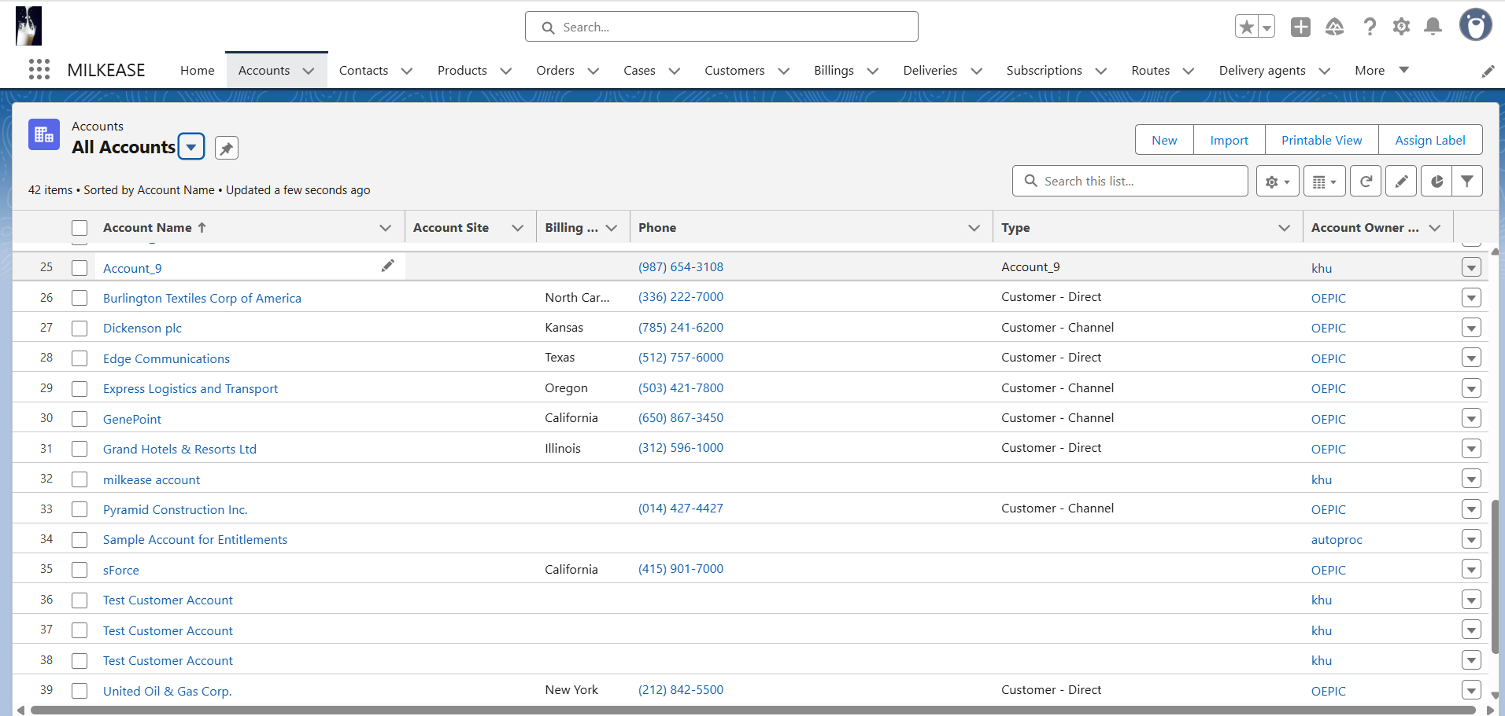

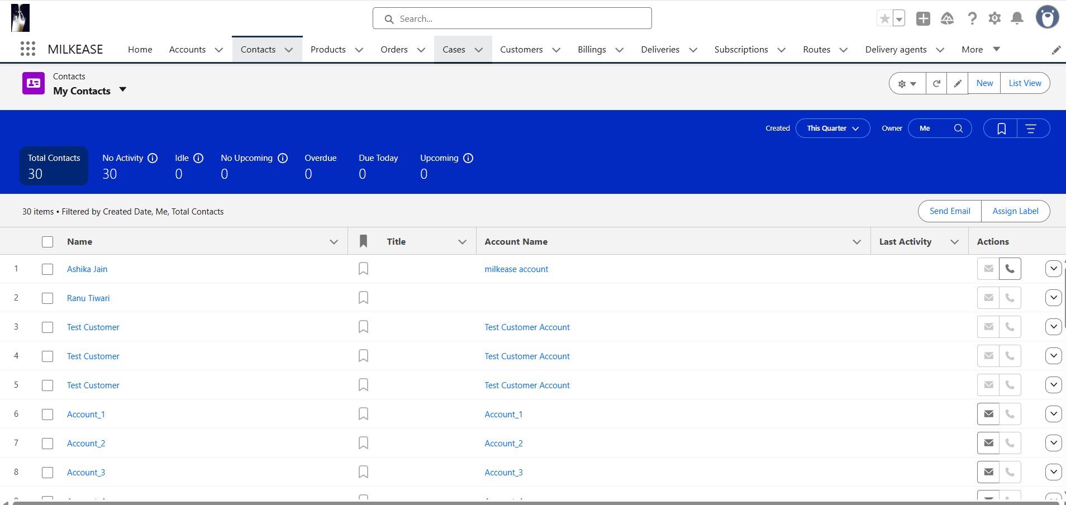

* Manually writing the other records.

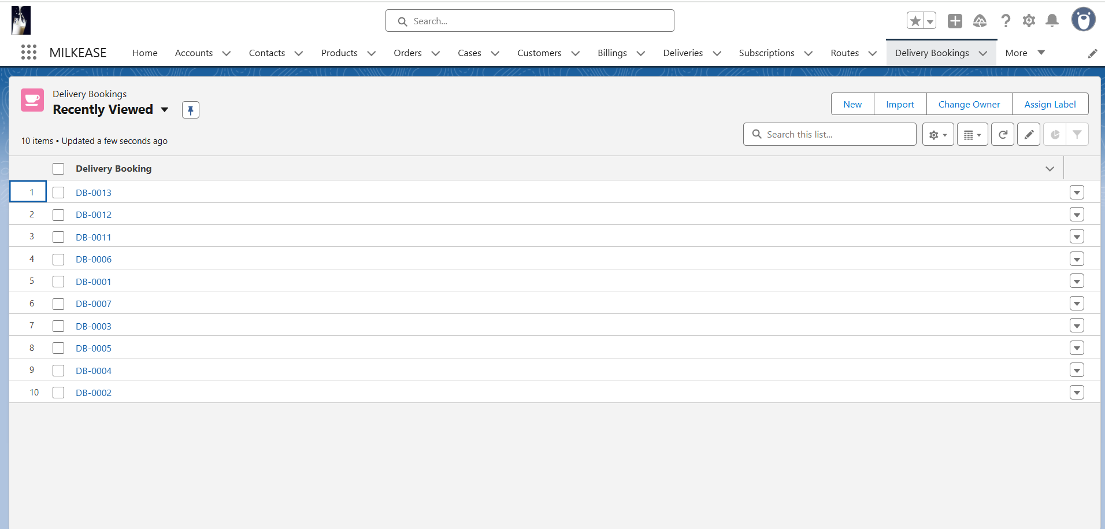

* **Data Loader**:-
* for bulk Bookings, Customers, Milk Products.

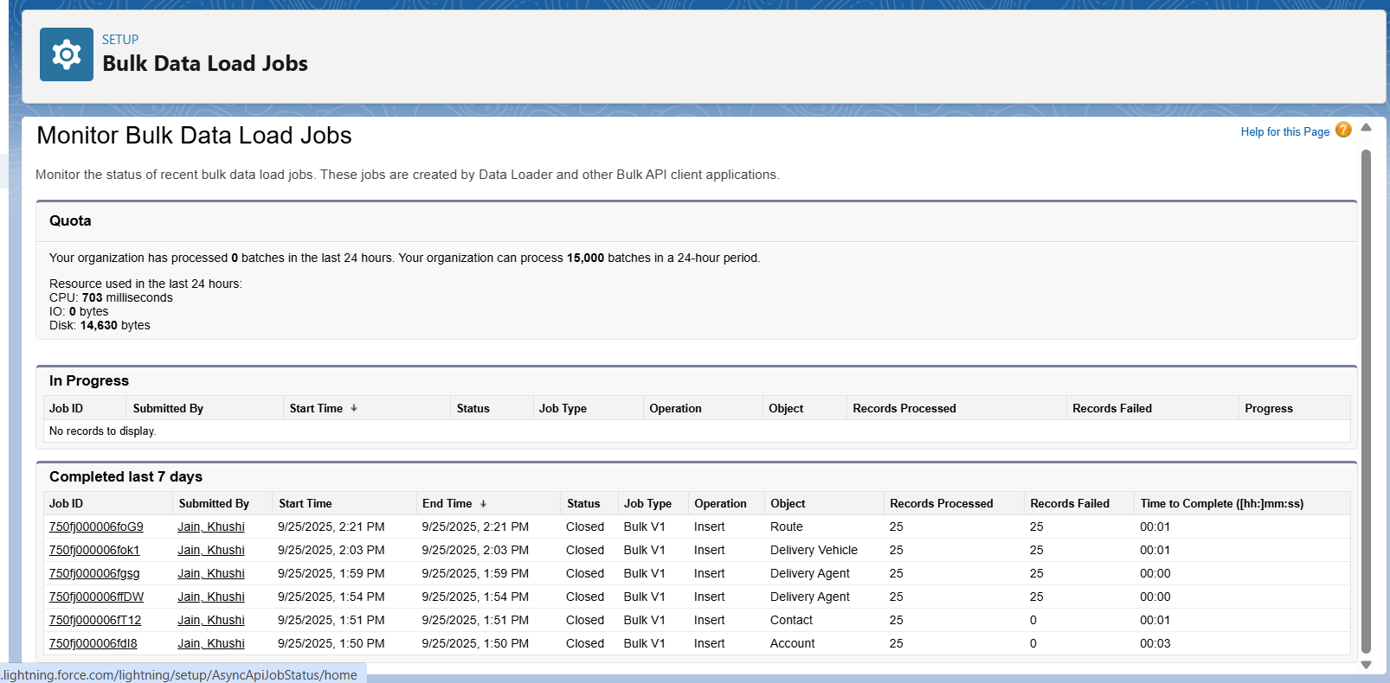

* **Duplicate Rule** :-
* For preventing duplicate delivery agent from login and account creation.

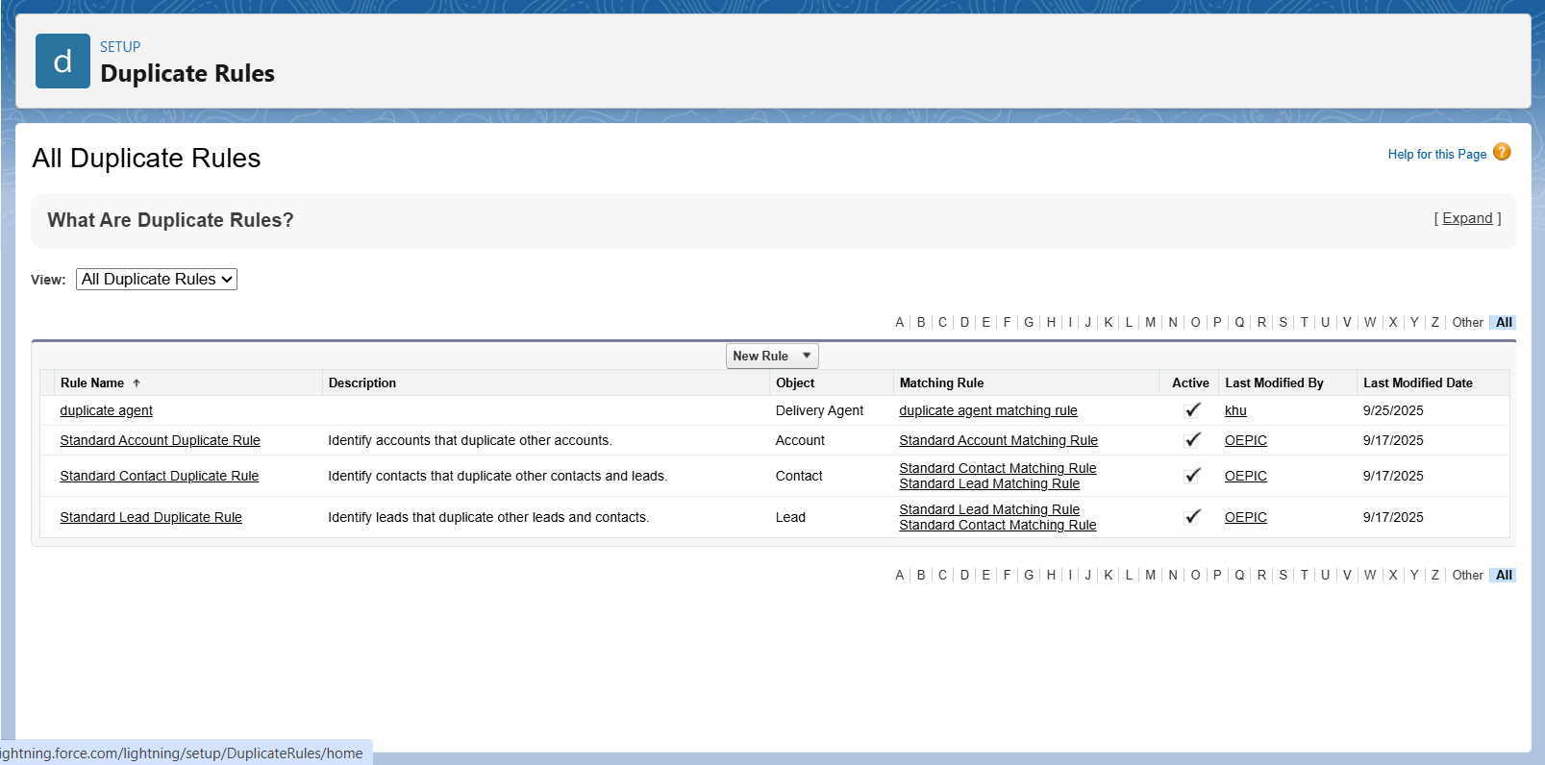

* **Matching Rule** :-
* For preventing duplicate delivery agent from login.

